Installation and Maintenance Instructions for BELLOWSFLEX™
Single-Ply and Multi-Ply Expansion Joints

- Piping system must be adequately anchored to limit the pipe movements the expansion joint must absorb. The expansion joint should be installed close to a main anchor, and should be followed by a pipe guide (within 4 pipe diameters) which prevents displacement of the line. If not installed adjacent to an anchor then a guide is required on both sides of the expansion joint (within 4 pipe diameters). See chart on back for intermediate guide spacing.
- Be sure all pipelines are supported so the expansion joint does not carry the pipe load.
- Be certain that the piping configuration does not impose torque on the expansion joint.
- System movement must not exceed expansion joint capability as shown on the label. Operation beyond design limits will result in premature failure.
- Tie rods or control rods are included on some joints to (1) limit over travel (2) absorb the pressure thrust in the event of a main anchor failure or (3) to absorb pressure thrust for systems designed for motion where no anchors are present. These rods are factory preset. The system design should be carefully reviewed for correct use of the rods. They can restrict travel if used incorrectly.
- Check system pressure and temperature and do not exceed the expansion joints capability as shown on the label. Operation beyond design limits will result in premature failure.
- Expansion joint alloy must be chemically compatible with the media in the piping system. If in doubt about suitability, refer to a Chemical Resistance Data Table or contact Flex-Hose Co. for guidance.

- Remove the flange protectors or end caps, packing materials, etc.; be certain that the joint interior is free of foreign material. Be certain that the joint is not damaged.
- Flow liners or sleeves that extend through the bore of the joint are included in some units. A stamp indicating the flow direction is on the external surface. The joint must be installed with flow as indicated.
- Align and support the piping adjacent to the expansion joint. Whenever possible, install all of the guides, supports, and anchors prior to inserting the expansion joint. The opening or length provided for the joint must be equal to the catalog or drawing length of the shipped joint. This shipped length of the expansion joint provides for the rated axial compression and extension as shown on the attached tag and in the catalog.
- The shipping bar is tack welded or soldered to the expansion joint at the factory to insure rated movement. Do not remove this bar until the installation is complete – all anchors, guides and supports have been adjusted. Remove the restraint prior to testing and remove the tack weld. The restraint is not designed to react to pressure thrust.
- Maintenance: BELLOWSFLEX expansion joints do not require maintenance other than routine cleaning and painting to prevent external corrosion. If water is introduced into a steam system, the expansion joint must be drained to prevent flashing and water hammer.

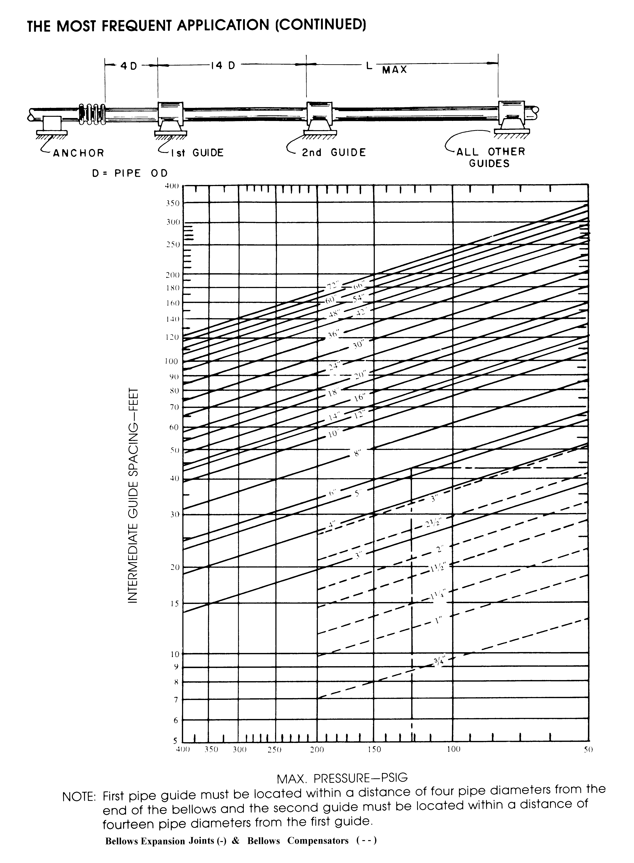
Special Note: The diagram above is for typical non-externally pressurized expansion joints. After placement of the first guide, use the chart above for the spacing of intermediate guides.

